Prometic Report List

**Chris Johnson March 2016**

**Version 0.6**

|  |  |  |
| --- | --- | --- |
| Version number | Description | Date of version |
| 0.1 | First draft | 10th March 2016 |
| 0.2 | Moved Currency rates to System Reports  Added Actual Budgets GL Group Maps  Added General Ledger Journal Entries  Updated Lot Traceability to include batch numbers | 18th March 2016 |
| 0.3 | Added reports   * Closing Interco Balances * Open Purchase Zero Value * Missing RI2 GL Groups | 8th April 2016 |
| 0.4 | Added reports   * Open Requisition Report * Gen Ledger Control Panel | 13th April 2016 |
| 0.5 | Added report   * GL Center Summary | 14th April 2016 |
| 0.6 | Added report   * GL Cash Position | 15th April 2016 |

**Distribution List**

|  |  |  |
| --- | --- | --- |
| Name | Position | Date sent |
| Sophie Talon-Bergeron | Finance Manager | * 10th March 2016 * 13th April 2016 |
| Bianca Vasquez | Financial Analyst | * 10th March 2016 * 13th April 2016 |
| Liz Collins | Financial Controller | * 10th March 2016 * 13th April 2016 |
| Benjamin Hémond | Procurement Specialist | 10th March 2016 |
| Hassan Mamdani | Research Scientist Computational Chemist | 10th March 2016 |
| David Franklin | Head of Financial Planning and Analysis | 10th March 2016 |
| Jacqueline Richard | Head of Financial Reporting | 10th March 2016 |
| Bruce Pritchard | COO | 10th March 2016 |
| Greg Weaver | CFO | 10th March 2016 |

**Introduction**

This is a brief list of all reports that are currently available as held within the Syspro ERP system with a brief description of

* What the report does
* What the parameters of the report relate to
* What the report looks like

Any reports that are held in the development folder are awaiting sign off from the business before being released.

Any reports that have been written limiting them to a single company are scheduled to be removed as soon as replacements have been signed off and therefore have not been included in this document.

Contents

Folder – System Reports 3

Batch Profitability 3

Currency Rates 4

Job Lot Breakdown 5

Folder – System Accounts Payable 6

AP Aged Analysis Alt 6

AP Unpaid Assets 7

Payment Run 8

Folder – System Assets 9

Fixed Asset List Live 9

Folder – System General Ledger 10

Closing Interco Balances 10

Gen Ledger Control Panel 11

GRN Unpaid assets 12

Folder – System Inventory 13

Lot Retesting 13

Stock Levels 14

Inventory Inspection Times 15

Folder – System Management Accounts 16

Folder – System Purchase Orders 17

Purchase Order Changes 17

Open Purchase Orders 18

Open Purchase Zero Order 19

Open Requisition Report 20

Requisition users 21

Folder – System Sales Orders 22

Sales Orders Status 22

Sales by Job 23

Sales Order KPI 24

Folder – System WIP 25

Job Lot Output 25

Folder – Development 26

Actuals Budgets GL Group Maps 26

Actuals Budgets Report Index Maps 27

Actuals Budgets Balance Sheet 28

GL Cash Position 29

GL Center Summary 30

General Ledger Journal Entries 31

GRN Unpaid Assets 32

Inventory in Inspection 33

Labour Ledger Comparison 34

Lot Traceability 35

Missing RI2 GLGroups 36

Open Requisition Report 37

Open Purchase Orders Stock 38

Payment Run 39

Pick List 40

Pick List Job Breakdown 41

Pick List Reserved Lots 42

Pick List Work Centre 43

Purchase Order Details 44

Purchase Order E Signature 45

Unpaid Assets Accounts Payable 46

Reports to be developed 47

# Folder – System Reports

## Batch Profitability

|  |  |
| --- | --- |
| Description | Provide detail of jobs that have been actioned within a timeframe for a company, including labour cost, material cost and the amount sold |
| Requested by | David Franklin |
| Delivered Date | Oct 2015 |
| Used by | PBL |

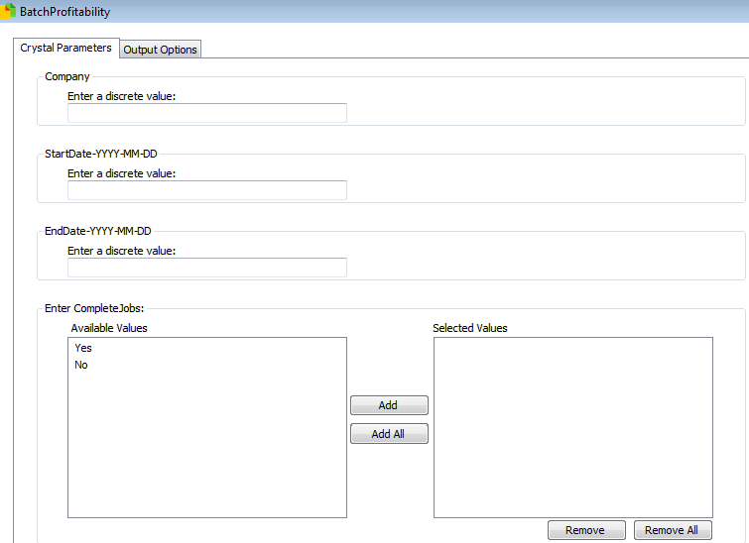Parameters

These are filters picked before running the report

* Company
  + The Syspro company ID to run against (PBL = 10)
* Start Date-YYYY-MM-DD
  + Beginning of the period to select jobs that started
* End Date-YYYY-MM-DD
  + End of the period to select jobs that started
* Complete Jobs
  + Yes – for only complete jobs
  + No – for only incomplete jobs

Final Report

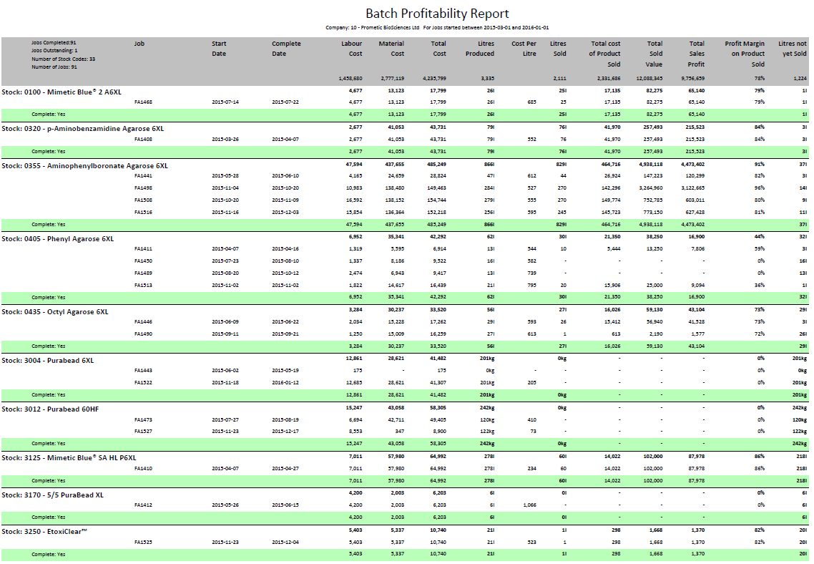

## Currency Rates

|  |  |
| --- | --- |
| Description | Details of historic currency rates |
| Requested by | Chris Johnson |
| Delivered Date | March 2016 |
| Used by | N/A |

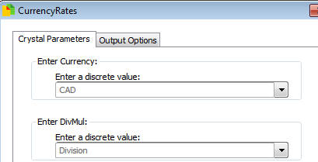Parameters

These are filters picked before running the report

* Currency
  + Choose currency to review
* DivMul
  + Division – show currency rates as a rate to divide figures by
  + Muliply – show currency rates as a rate to divide figures by

Final Report

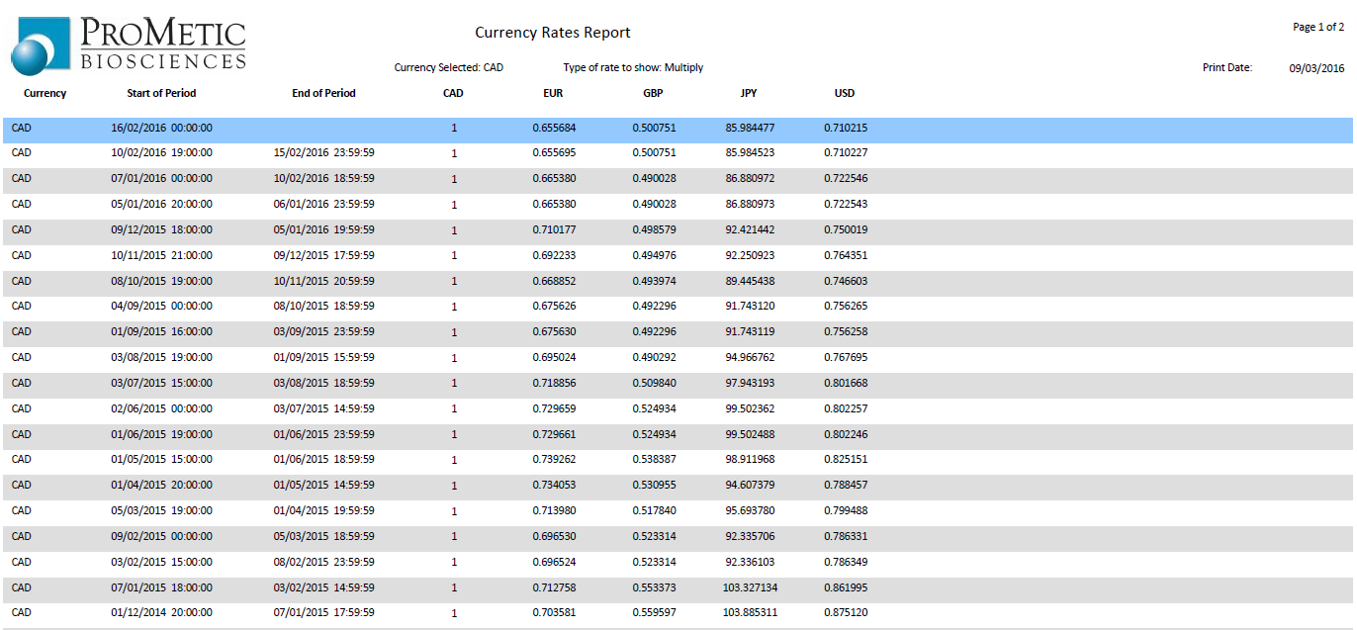

## Job Lot Breakdown

|  |  |
| --- | --- |
| Description | Syspro details of a job, showing labour, stock consumed, stock created and sales made |
| Requested by | David Franklin |
| Delivered Date | Nov 2015 |
| Used by | PBL |

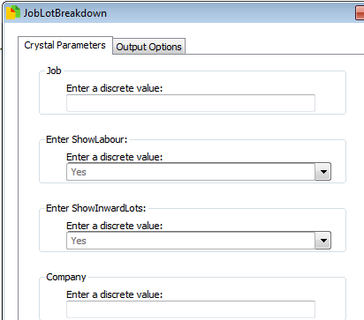Parameters

These are filters picked before running the report

* Company
  + The Syspro company ID to run against (PBL = 10)
* Job
  + The batch number to check
* Show Labour
  + Choose whether to show labour input into job
* Show Inward Lots
  + Choose whether to show Lots input into job

Final Report

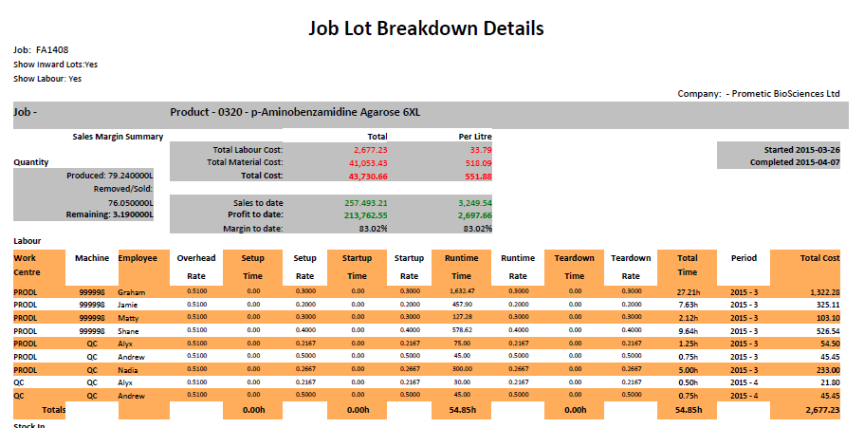

# Folder – System Accounts Payable

## AP Aged Analysis Alt

|  |  |
| --- | --- |
| Description | Revision of Syspro report correcting total fields |
| Requested by | Liz Collins |
| Delivered Date | Oct 2015 |
| Used by | PBL Finance |

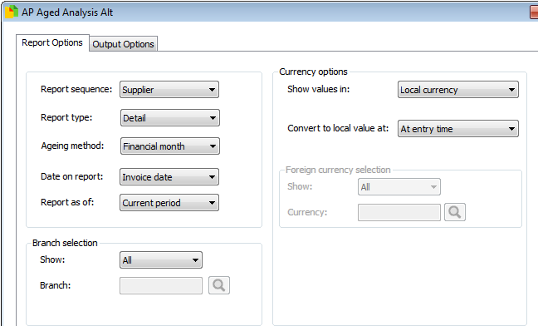Parameters

These are filters picked before running the report.

These parameters have been defined by Syspro.

Final Report

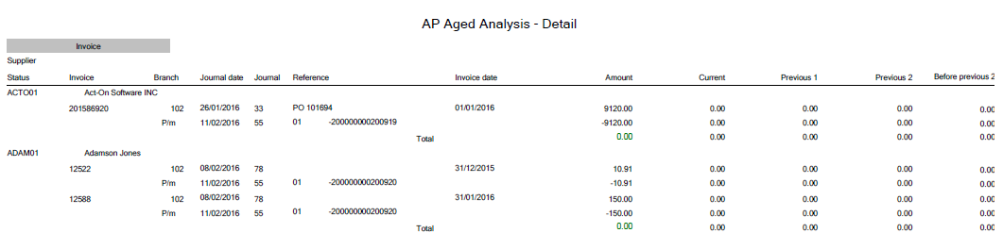

## AP Unpaid Assets

|  |  |
| --- | --- |
| Description | Accounts Payable – Unpaid Assets, created by Logi Solutions |
| Requested by | Bianca Vasquez |
| Delivered Date | - |
| Used by | PBI/PBL finance |

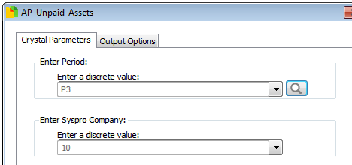Parameters

* Period
  + P1 = current period
  + P2 = previous period
  + P3 = previous period -1
* Syspro Company
  + The Syspro company ID to run against (PBL = 10)

Final Report

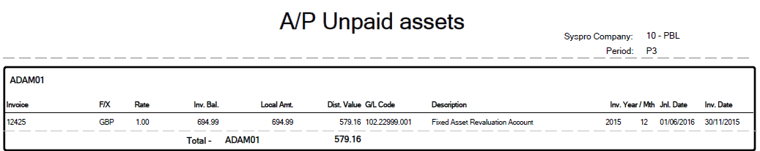

## Payment Run

|  |  |
| --- | --- |
| Description | Details of Payment Run with GRN matching for the creation of cheques |
| Requested by | Bianca Vasquez |
| Delivered Date | Dec 2015 |
| Used by | PBI Finance |

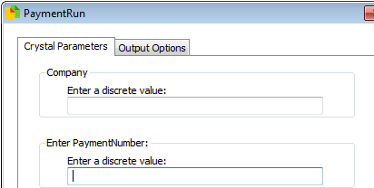Parameters

These are filters picked before running the report

* Company
  + The Syspro company ID to run against (PBL = 10)
* Payment Number
  + Syspro payment number to query

Final Report

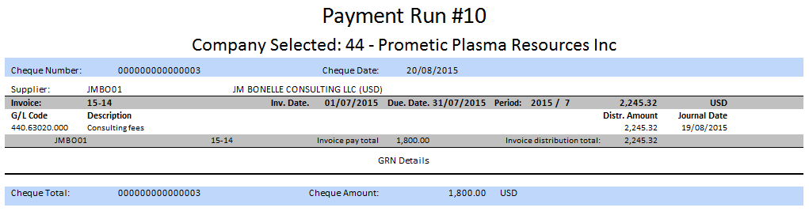

# Folder – System Assets

## Fixed Asset List Live

|  |  |
| --- | --- |
| Description | Details of fixed assets in Syspro |
| Requested by | Kirsty Wells |
| Delivered Date | Oct 2015 |
| Used by | PBL Finance |

Parameters

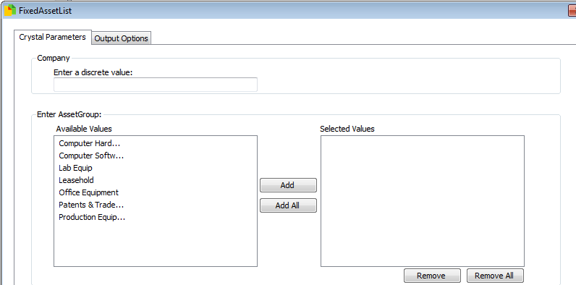These are filters picked before running the report

* Company
  + The Syspro company ID to run against (PBL = 10)
* Enter Asset Group
  + Pick which groups of assets that should be shown

Final Report

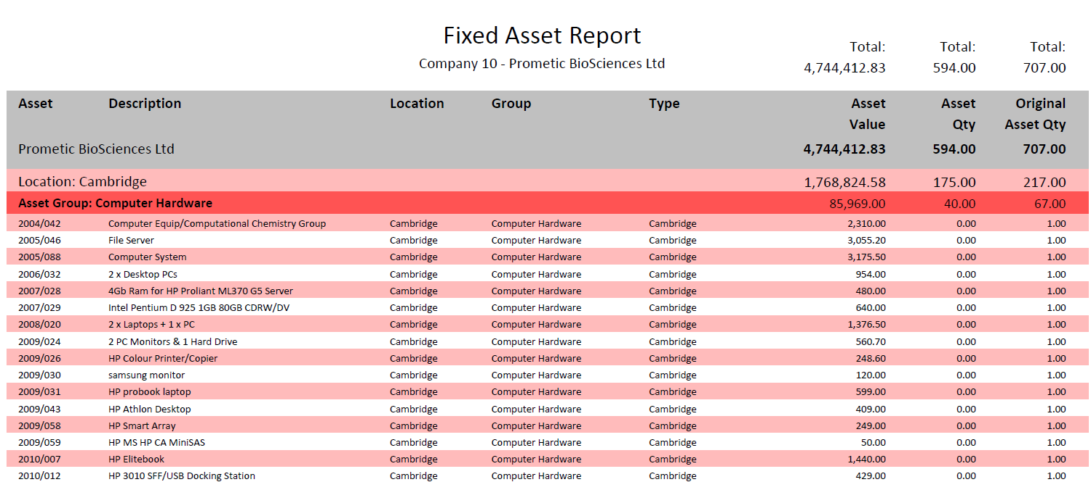

# Folder – System General Ledger

## Closing Interco Balances

|  |  |
| --- | --- |
| Description | Details of closing balances for intercompany payments |
| Requested by | Bianca Vasquez |
| Delivered Date | 7th April 2016 |
| Used by | PBI Finance |

Parameters

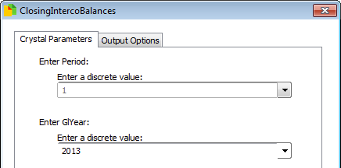These are filters picked before running the report

* Company
  + The Syspro company ID to run against (PBL = 10)
* Enter Period
  + Choose which GL period to review

Final Report

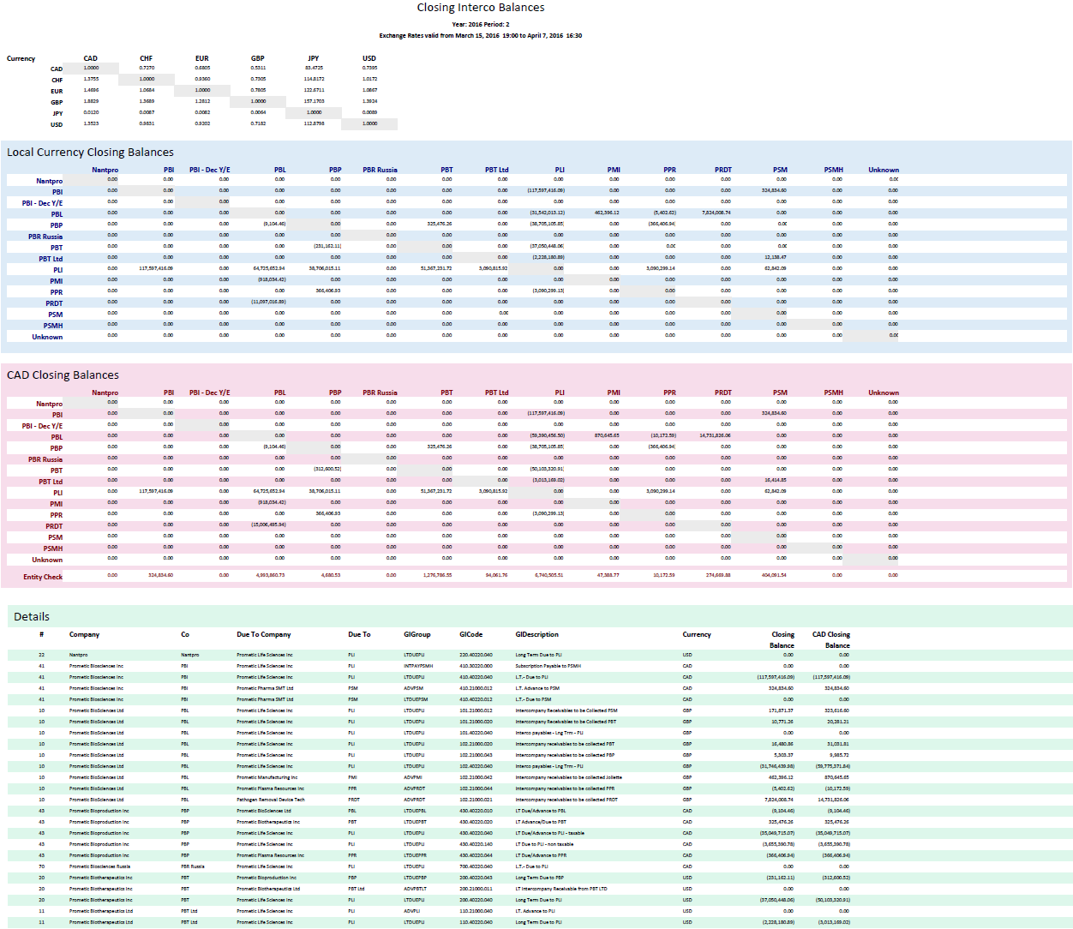

## Gen Ledger Control Panel

|  |  |
| --- | --- |
| Description | Details of current general ledger statistics |
| Requested by | Liz Collins |
| Delivered Date | 13th April 2016 |
| Used by | PBL Finance |

Parameters

No parameters required.

Final Report

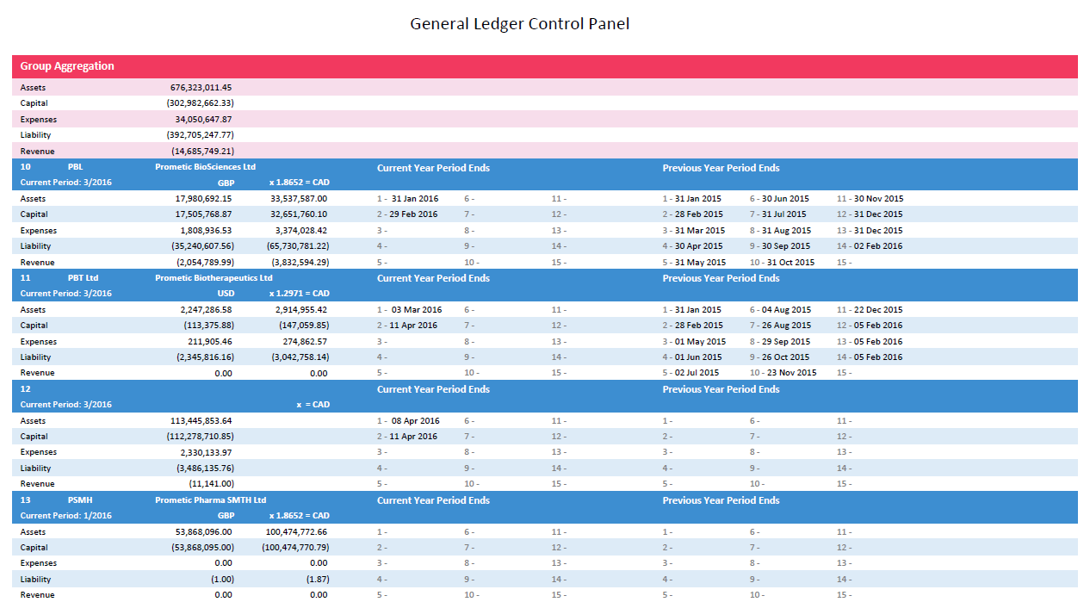

## GRN Unpaid assets

|  |  |
| --- | --- |
| Description | GRN Unpaid Assets – Logi solutions |
| Requested by | Bianca Vasquez |
| Delivered Date | - |
| Used by | PBI Finance |

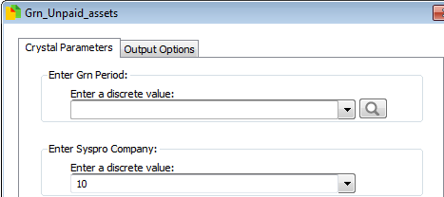Parameters

These are filters picked before running the report

* Company
  + The Syspro company ID to run against (PBL = 10)
* Enter Grn Period
  + Choose which GL period to review

Final Report

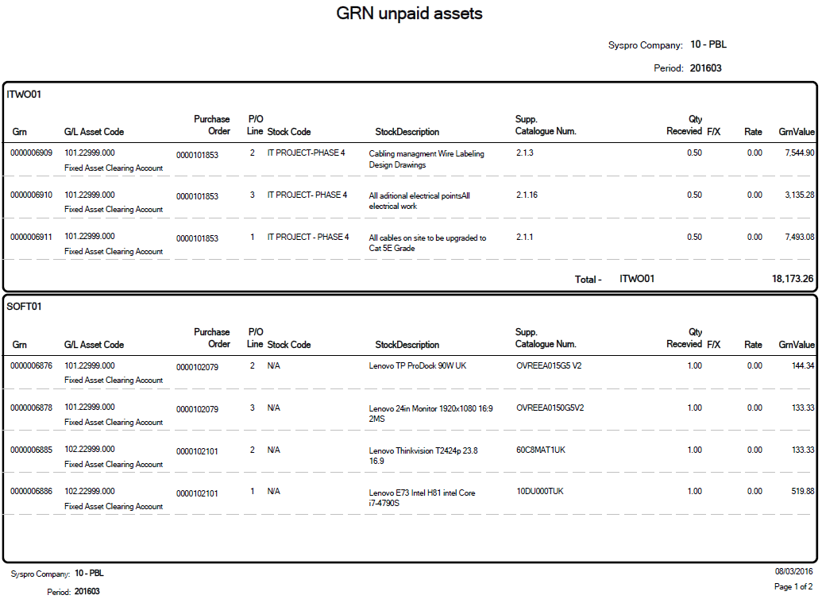

# Folder – System Inventory

## Lot Retesting

|  |  |
| --- | --- |
| Description | Allows Quality Control to know which lots need retesting within a period |
| Requested by | QC |
| Delivered Date | Dec 2015 |
| Used by | PBL QC |

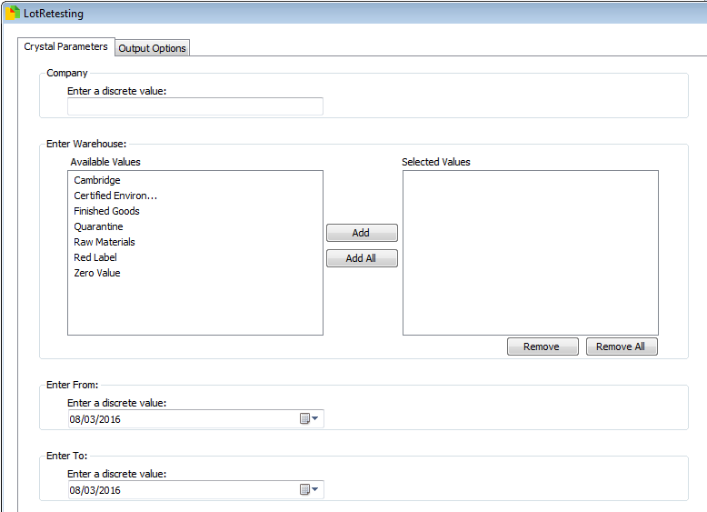Parameters

These are filters picked before running the report

* Company
  + The Syspro company ID to run against (PBL = 10)
* Warehouse
  + Which warehouse to review
* Enter From
  + Start of period for expiry dates
* Enter To
  + Start of period for expiry dates

Final Report

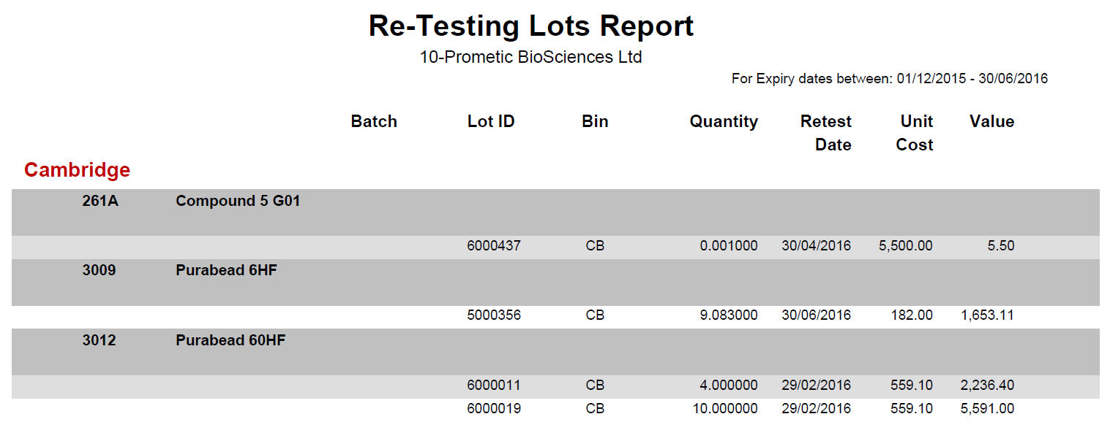

## Stock Levels

|  |  |
| --- | --- |
| Description | Details of all stock held in Syspro |
| Requested by | Liz Collins |
| Delivered Date | Nov 2015 |
| Used by | PBL Finance |

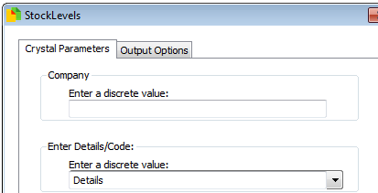Parameters

These are filters picked before running the report

* Company
  + The Syspro company ID to run against (PBL = 10)
* Details/Code
  + Details – show movements
  + Code – show overall level per stock code

Final Report

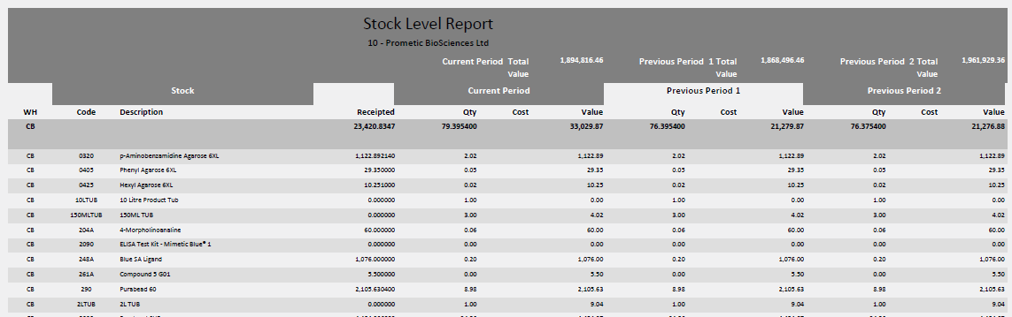

## Inventory Inspection Times

|  |  |
| --- | --- |
| Description | Review of how long stock spends in inventory before being approved |
| Requested by | Andrew Hafford |
| Delivered Date | Feb 2016 |
| Used by | PBL QC & Finance |

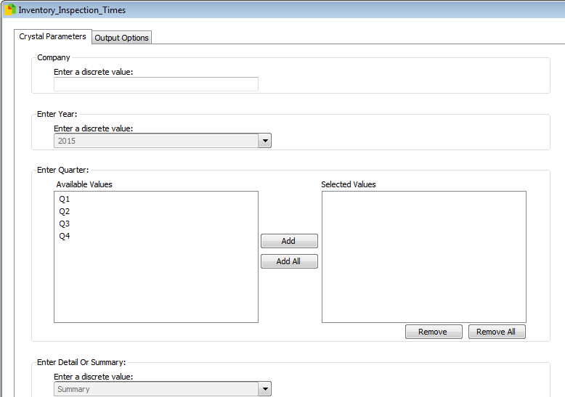Parameters

These are filters picked before running the report

* Company
  + The Syspro company ID to run against (PBL = 10)
* Year
  + Choose the year to review
* Quarter
  + Choose the quarter to review
* Detail or Summary
  + Detail – show each lot
  + Summary – show a summary line per stock code and delivery date

Final Report

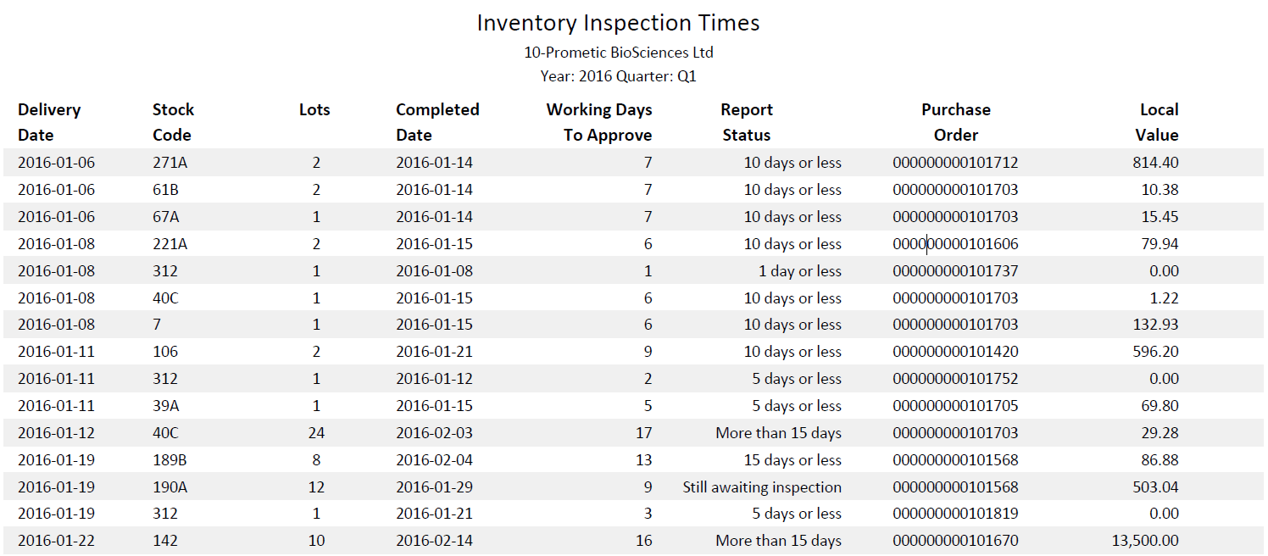

# Folder – System Management Accounts

This folder is a placeholder for the Actual & Budgets reports

# Folder – System Purchase Orders

## Purchase Order Changes

|  |  |
| --- | --- |
| Description | Monitoring of Purchase Orders to see changes in Price and Value |
| Requested by | Bianca Vasquez |
| Delivered Date | Dec 2015 |
| Used by | PBI Finance |

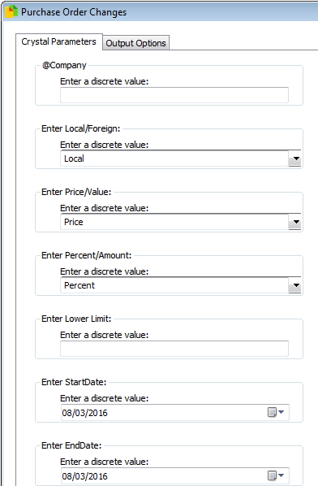Parameters

These are filters picked before running the report

* Company
  + The Syspro company ID to run against (PBL = 10)
* Local/Foreign
  + Whether to use the local or settlement currency figures for comparison
* Price/Value
  + Price – check differences in price
  + Value – check differences in value (price x quantity)
* Percent/Amount
  + Percent – check difference in percent
  + Amount – check difference in value
* Lower Limit
  + Only show changes about this amount
* StartDate
  + Start of period for changes
* EndDate
  + End of period for changes

Final Report

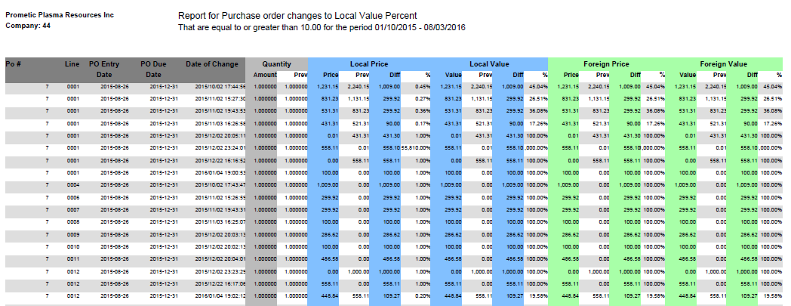

## Open Purchase Orders

|  |  |
| --- | --- |
| Description | Monitoring of Purchase Orders that are outstanding |
| Requested by | Liz Collins/Colin Martin |
| Delivered Date | Dec 2016 |
| Used by | PBL Finance & Purchasing |

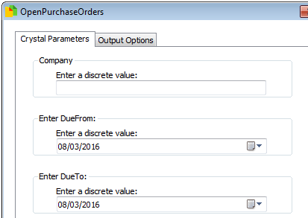Parameters

These are filters picked before running the report

* Company
  + The Syspro company ID to run against (PBL = 10)
* Due From
  + Start of due date period
* Due To
  + End of due date period

Final Report

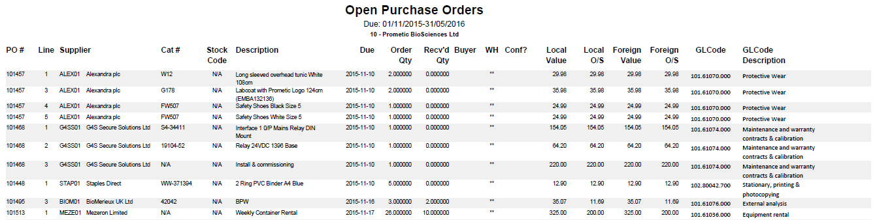

## Open Purchase Zero Order

|  |  |
| --- | --- |
| Description | Monitoring of Purchase Orders that are open and have a price of zero |
| Requested by | Matt Fantham |
| Delivered Date | 8th April 2016 |
| Used by | PBL Purchasing |

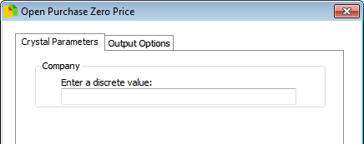Parameters

These are filters picked before running the report

* Company
  + The Syspro company ID to run against (PBL = 10)

Final Report

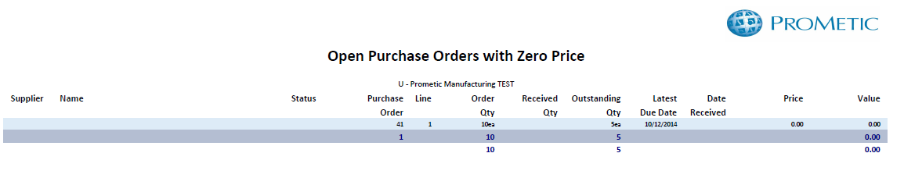

## Open Requisition Report

|  |  |
| --- | --- |
| Description | Monitoring of Requisitions that are outstanding |
| Requested by | Benjamin Hémond |
| Delivered Date | 13th April 2016 |
| Used by | PBI Purchasing |

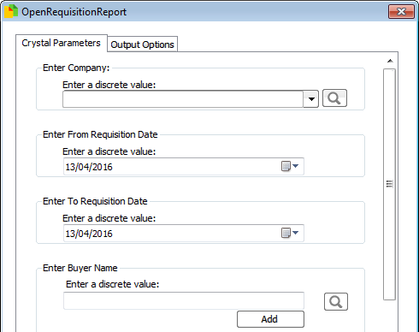Parameters

These are filters picked before running the report

* Company
  + The Syspro company ID to run against (PBL = 10)
* From Requisition Date
  + Beginning of period to query
* To Requisition Date
  + End of period to query
* Buyer Name
  + Buyer to query (if left blank then all buyers selected)

Final Report

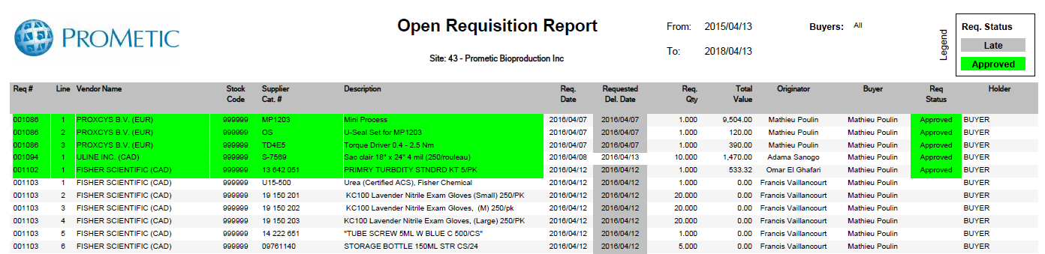

## Requisition users

|  |  |
| --- | --- |
| Description | Details of Syspro Users & their requisition approval limits |
| Requested by | Liz Collins |
| Delivered Date | Feb 2016 |
| Used by | PBL Finance |

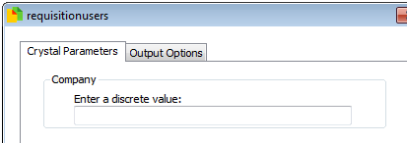Parameters

These are filters picked before running the report

* Company
  + The Syspro company ID to run against (PBL = 10)

Final Report

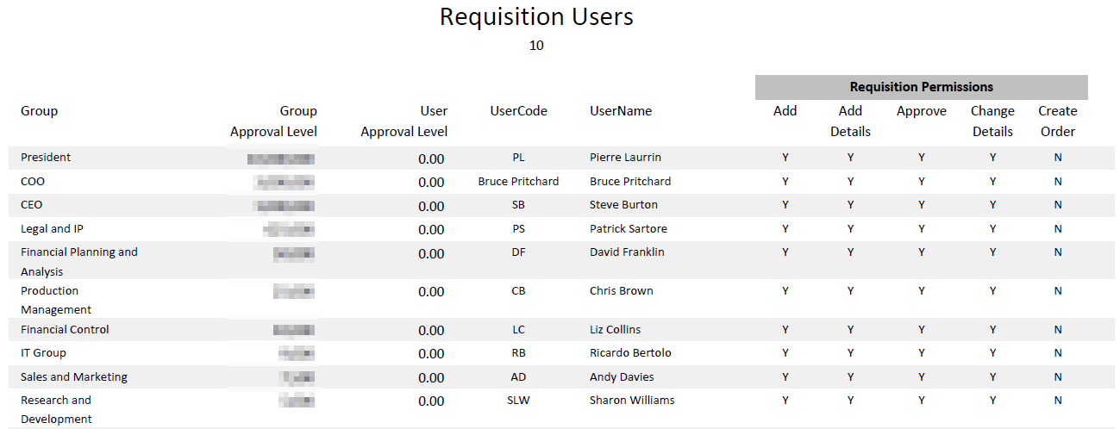

# Folder – System Sales Orders

## Sales Orders Status

|  |  |
| --- | --- |
| Description | Details of Sales Orders |
| Requested by | Liz Collins/Shrinal Imamdar |
| Delivered Date | Feb 2016 |
| Used by | PBL Sales/Finance |

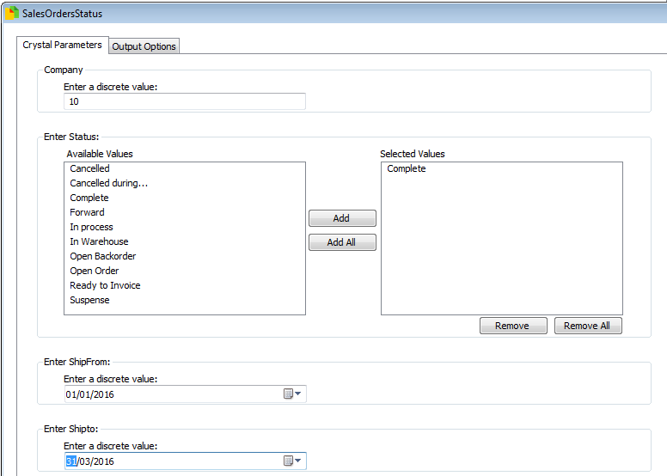Parameters

These are filters picked before running the report

* Company
  + The Syspro company ID to run against (PBL = 10)
* Status
  + Choose Sales Order Status
* Ship from
  + Start of ship date period
* Ship to
  + End of ship date period

Final Report

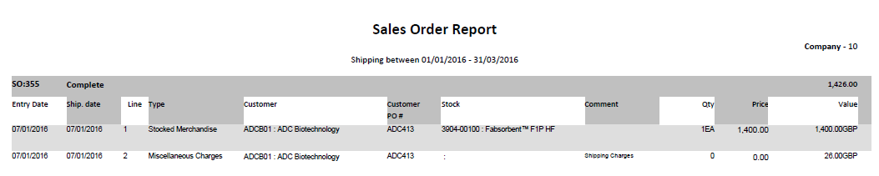

## Sales by Job

|  |  |
| --- | --- |
| Description | Details of Sales that are related to a manufacturing jobs |
| Requested by | Shrinal Imamdar |
| Delivered Date | Jan 2016 |
| Used by | PBL Sales |

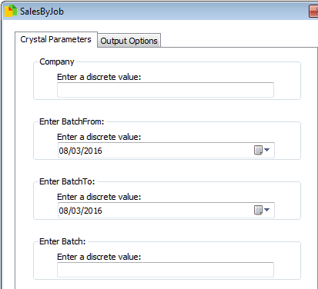Parameters

These are filters picked before running the report

* Company
  + The Syspro company ID to run against (PBL = 10)
* Batch from
  + Start of transaction date period
* Batch to
  + End of transaction date period
* Batch
  + Syspro Job to review

Final Report

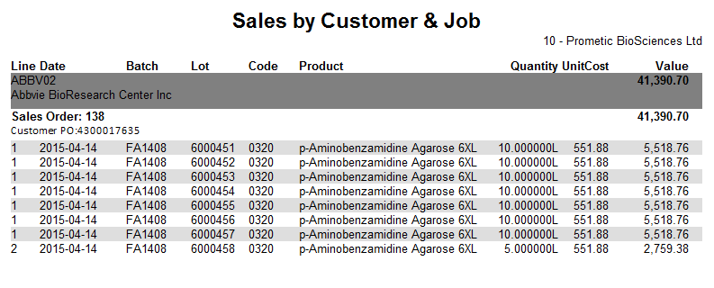

## Sales Order KPI

|  |  |
| --- | --- |
| Description | Monitoring of whether production have met the agreed date in Sales |
| Requested by | Ross Moore |
| Delivered Date | Feb 2016 |
| Used by | PBL Manufacturing |

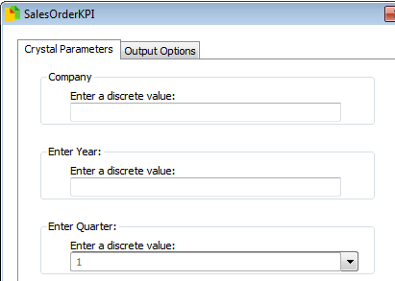Parameters

These are filters picked before running the report

* Company
  + The Syspro company ID to run against (PBL = 10)
* Year
  + Year to review
* Quarter
  + Quarter to review

Final Report

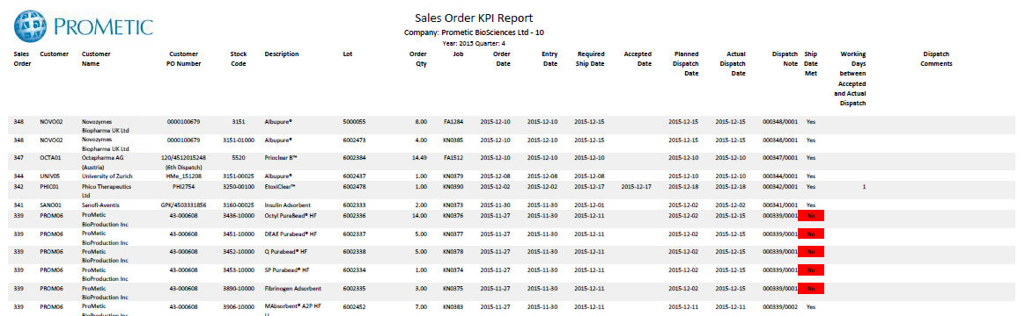

# Folder – System WIP

## Job Lot Output

|  |  |
| --- | --- |
| Description | Details of lots created from job and where they have been used |
| Requested by | Ross Moore |
| Delivered Date | Nov 2015 |
| Used by | PBL Manufacturing |

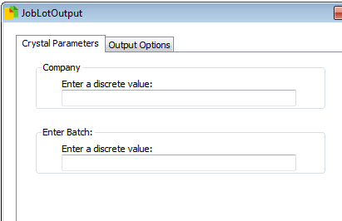Parameters

These are filters picked before running the report

* Company
  + The Syspro company ID to run against (PBL = 10)
* Batch
  + Syspro manufacturing job to review

Final Report

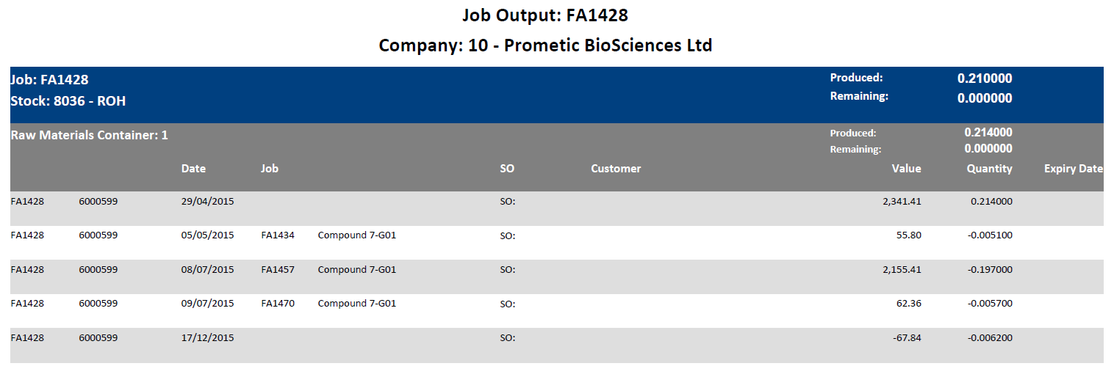

# Folder – Development

## Actuals Budgets GL Group Maps

|  |  |
| --- | --- |
| Description | Review of GL Group maps for use in other reports |
| Requested by | Bruce Pritchard |
| Delivered Date | N/A |
| Used by | N/A |

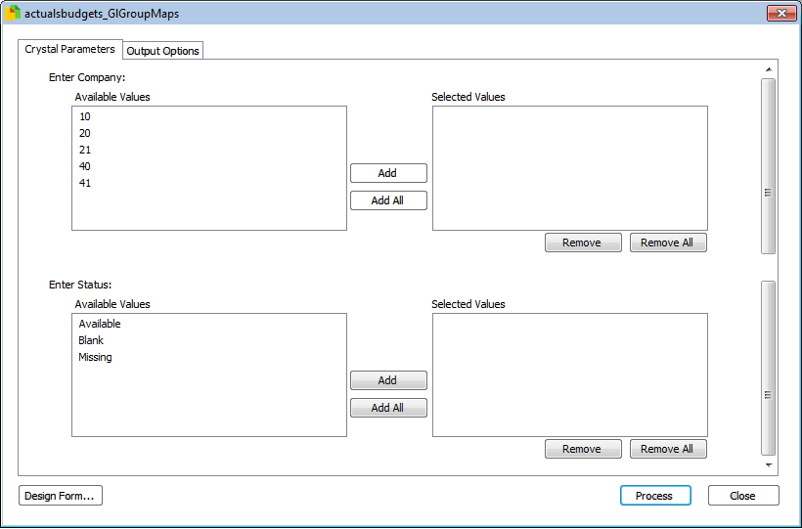Parameters

These are filters picked before running the report

* Company
  + The Syspro company ID to run against (PBL = 10)
* Status
  + Available – group has a mapping entered
  + Blank – group has a mapping that is blank, meaning it will not appear in reports
  + Missing – group does not have a map

Final Report

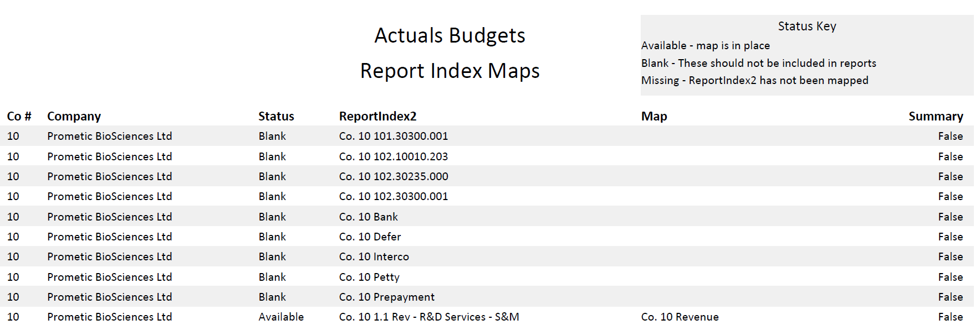

## Actuals Budgets Report Index Maps

|  |  |
| --- | --- |
| Description | Review of Report Index 2 maps for use in other reports |
| Requested by | Bruce Pritchard |
| Delivered Date | N/A |
| Used by | N/A |

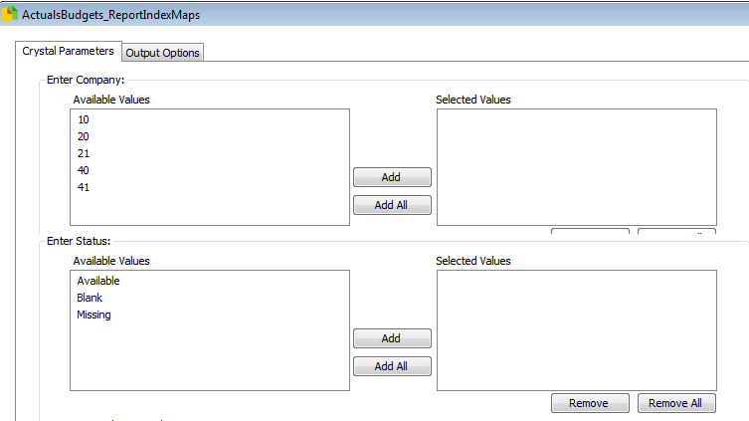Parameters

These are filters picked before running the report

* Company
  + The Syspro company ID to run against (PBL = 10)
* Status
  + Available – group has a mapping entered
  + Blank – group has a mapping that is blank, meaning it will not appear in reports
  + Missing – group does not have a map

Final Report

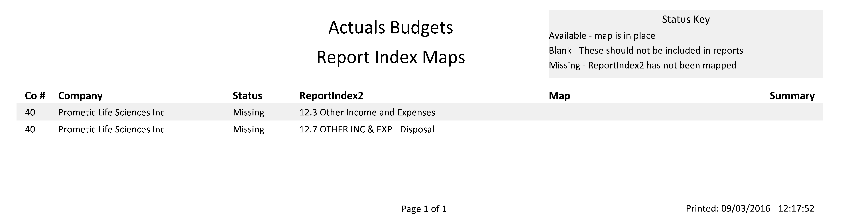

## Actuals Budgets Balance Sheet

|  |  |
| --- | --- |
| Description | Balance Sheet |
| Requested by | Bruce Pritchard |
| Delivered Date | N/A |
| Used by | N/A |

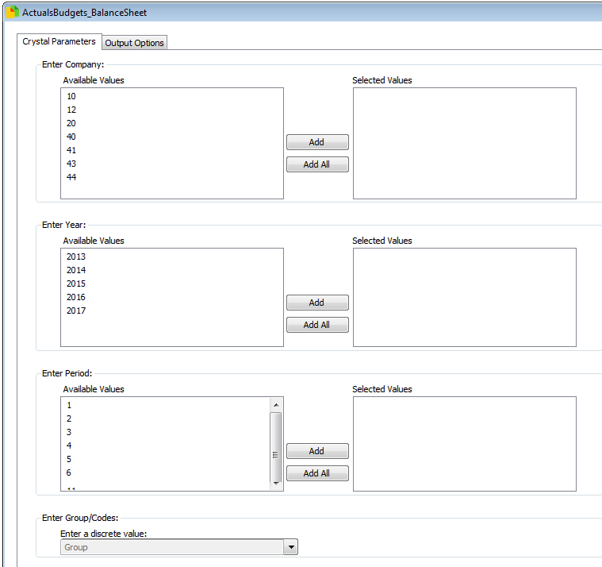Parameters

These are filters picked before running the report

* Company
  + The Syspro company ID to run against (PBL = 10)
* Year
  + Choose year
* Period
  + Choose period
* Group/Code
  + Group – Show GL Group summary
  + Code – show GL code details

Final Report

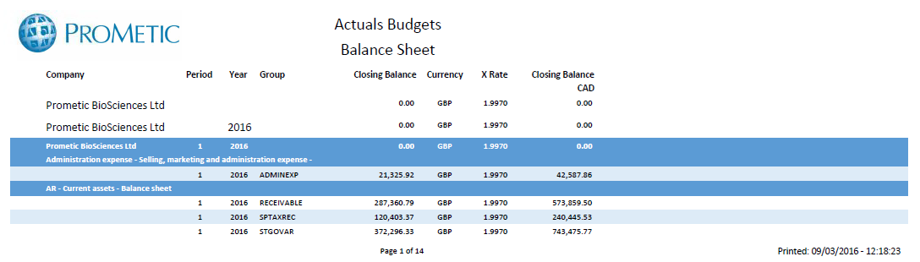

## GL Cash Position

|  |  |
| --- | --- |
| Description | Easy querying of GL for cash positions |
| Requested by | Greg Weaver |
| Delivered Date | N/A |
| Used by | N/A |

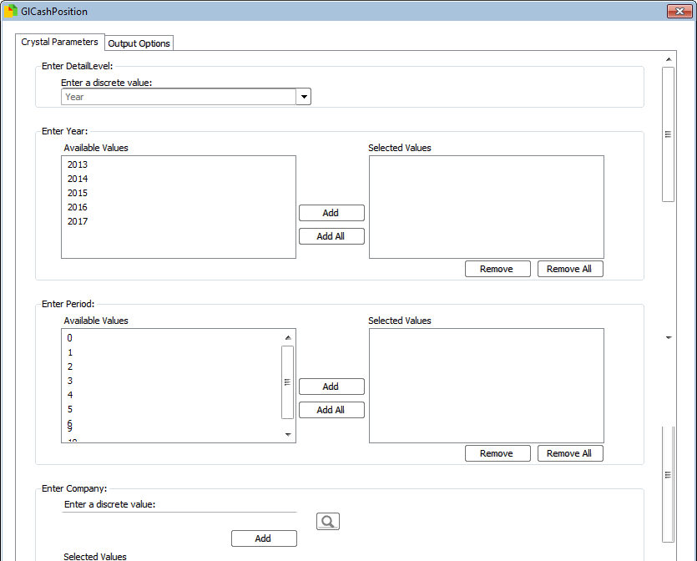Parameters

These are filters picked before running the report

* DetailLevel
  + Year – only show one figure for the year for each company
  + GlCode – show the summed entries for each GlCode in each company
  + Period – show the summed entries for each period, per GlCode and company
  + Journal – show the journal lines
* Enter Year
  + Choose year to query
* Enter Period
  + Choose periods to query (for Q1, add 0, 1, 2, 3
* Company
  + The Syspro company ID to run against (PBL = 10) – if no company is selected then all companies will be shown

Final Report

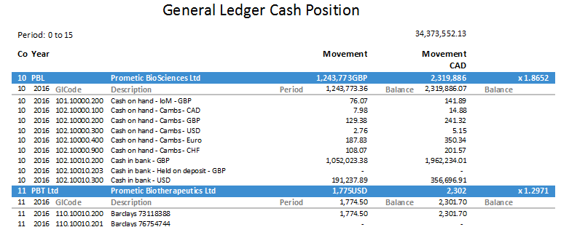

## GL Center Summary

|  |  |
| --- | --- |
| Description | Allow easy querying of GL items, such as current assets and cash |
| Requested by | Greg Weaver |
| Delivered Date | N/A |
| Used by | N/A |

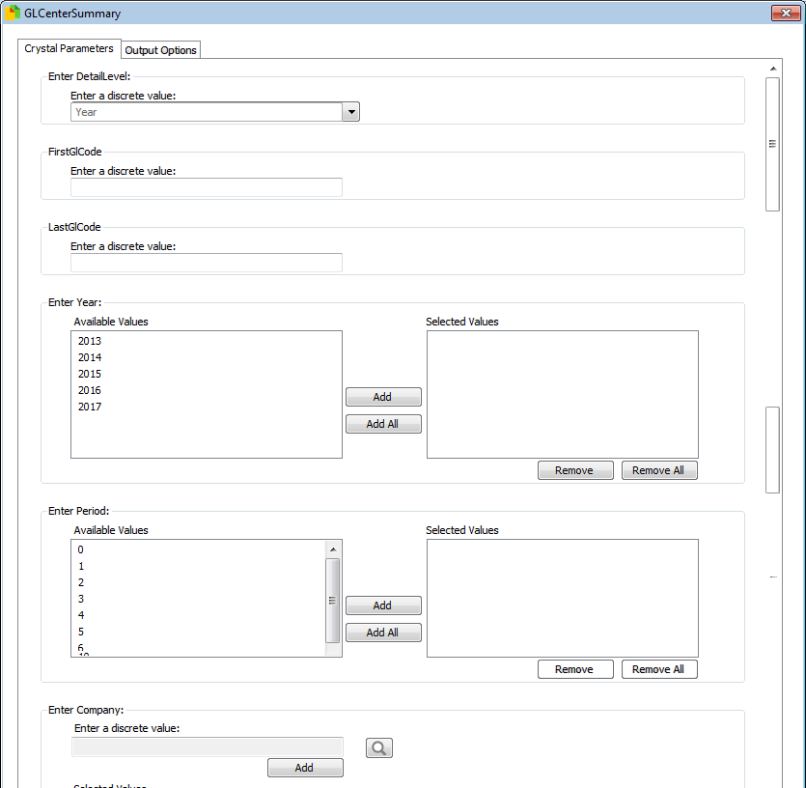Parameters

These are filters picked before running the report

* DetailLevel
  + Year – only show one figure for the year for each company
  + GlCode – show the summed entries for each GlCode in each company
  + Period – show the summed entries for each period, per GlCode and company
  + Journal – show the journal lines
* First GlCode
  + Choose the start of the Gl range to query
* Last GlCode
  + Choose the start of the Gl range to query
* Enter Year
  + Choose year to query
* Enter Period
  + Choose periods to query (for Q1, add 0, 1, 2, 3
* Company
  + The Syspro company ID to run against (PBL = 10) – if no company is selected then all companies will be shown

Final Report

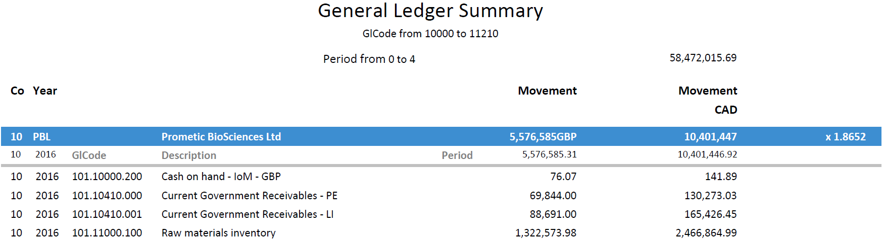

## General Ledger Journal Entries

|  |  |
| --- | --- |
| Description | Details of journal entries that can be exported to excel for further queries |
| Requested by | Bianca Vasquez |
| Delivered Date | N/A |
| Used by | N/A |

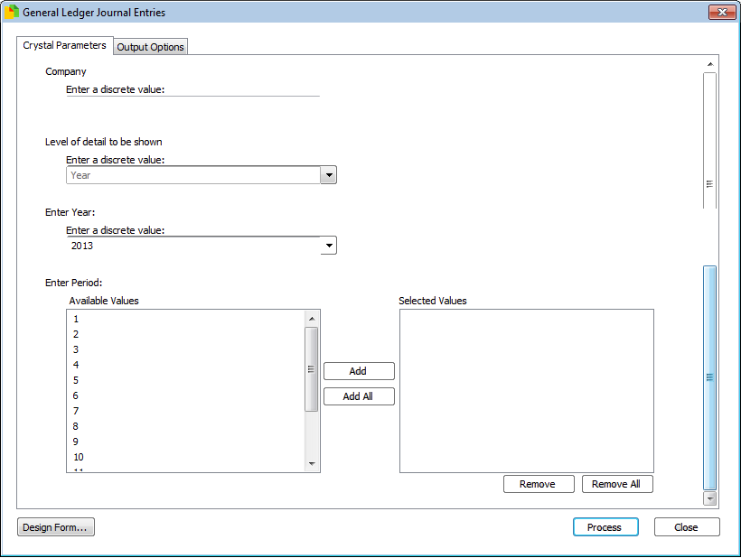Parameters

These are filters picked before running the report

* Company
  + The Syspro company ID to run against (PBL = 10)
* Level of detail to be shown
  + Year = only show a line per year
  + Period = show year and a line per period
  + Journal = show year, period and a summary of each journal
  + Year = which GL year to query
  + Enter Period = which GL period to query

Final Report

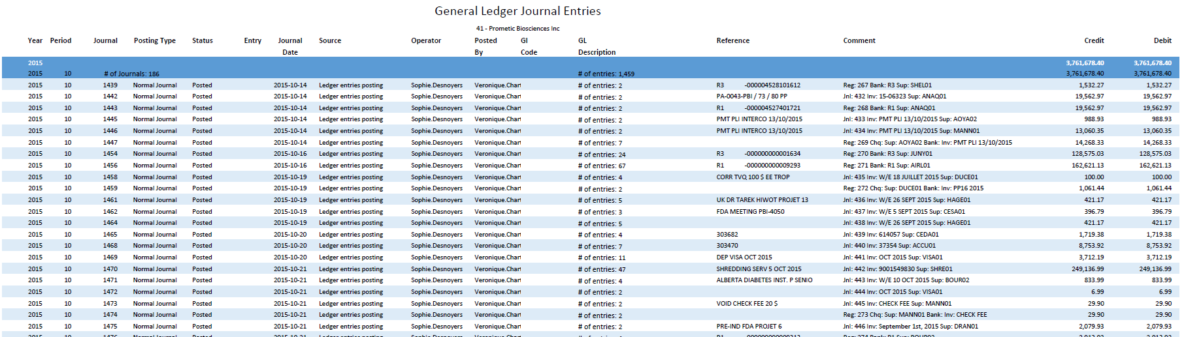

## GRN Unpaid Assets

|  |  |
| --- | --- |
| Description | GRN Unpaid Assets – Prometic |
| Requested by | Bianca Vasquez |
| Delivered Date | - |
| Used by | PBI Finance |

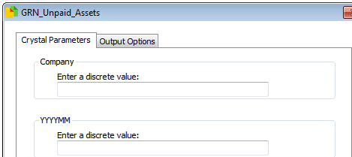Parameters

These are filters picked before running the report

* Company
  + The Syspro company ID to run against (PBL = 10)
* YYYYMM
  + GL Period to run against

Final Report

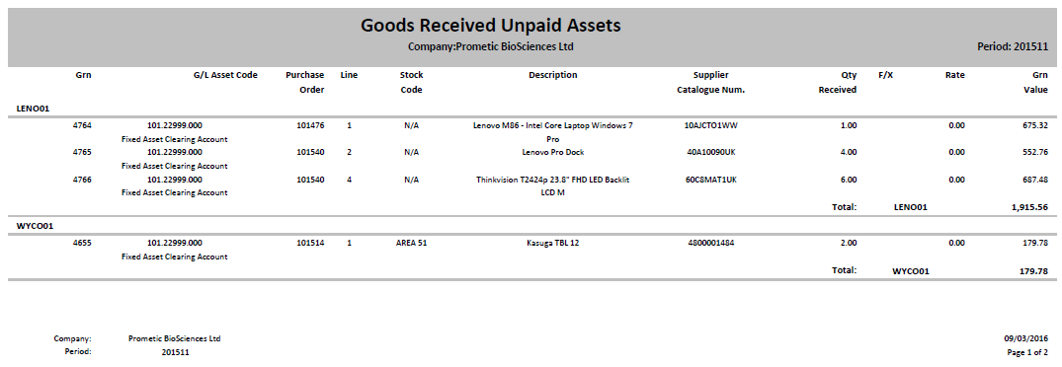

## Inventory in Inspection

|  |  |
| --- | --- |
| Description | Monitoring of items awaiting release from Inspection |
| Requested by | Matt Fantham |
| Delivered Date | N/A |
| Used by | PBL Manufacturing, Finance & Purchasing |

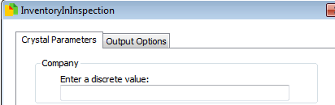Parameters

These are filters picked before running the report

* Company
  + The Syspro company ID to run against (PBL = 10)

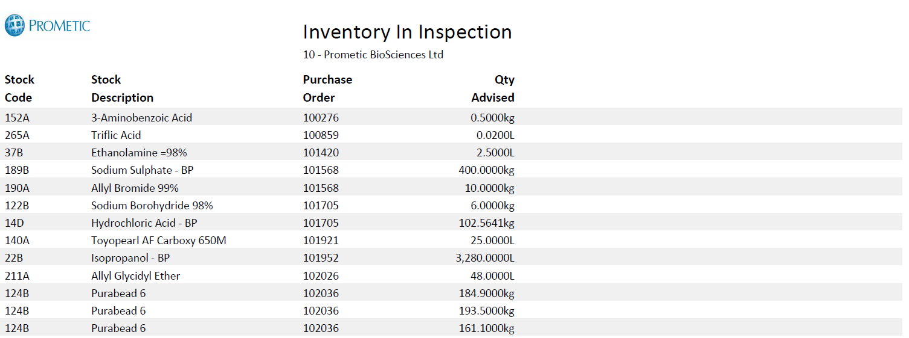

## Labour Ledger Comparison

|  |  |
| --- | --- |
| Description | Comparison of Labour logged and ledger entries over a period of time |
| Requested by | David Franklin |
| Delivered Date | N/A |
| Used by | N/A |

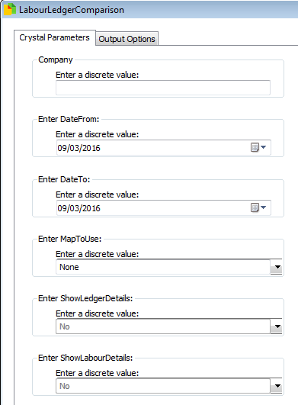Parameters

These are filters picked before running the report

* Company
  + The Syspro company ID to run against (PBL = 10)
* Date from
  + Start of period to run against
* Date to
  + End of period to run against
* Map to use
  + Which user map is to be shown in the report
* Show ledger details
  + Show ledger entries
* Show labour details
  + Show labour entries

Final Report

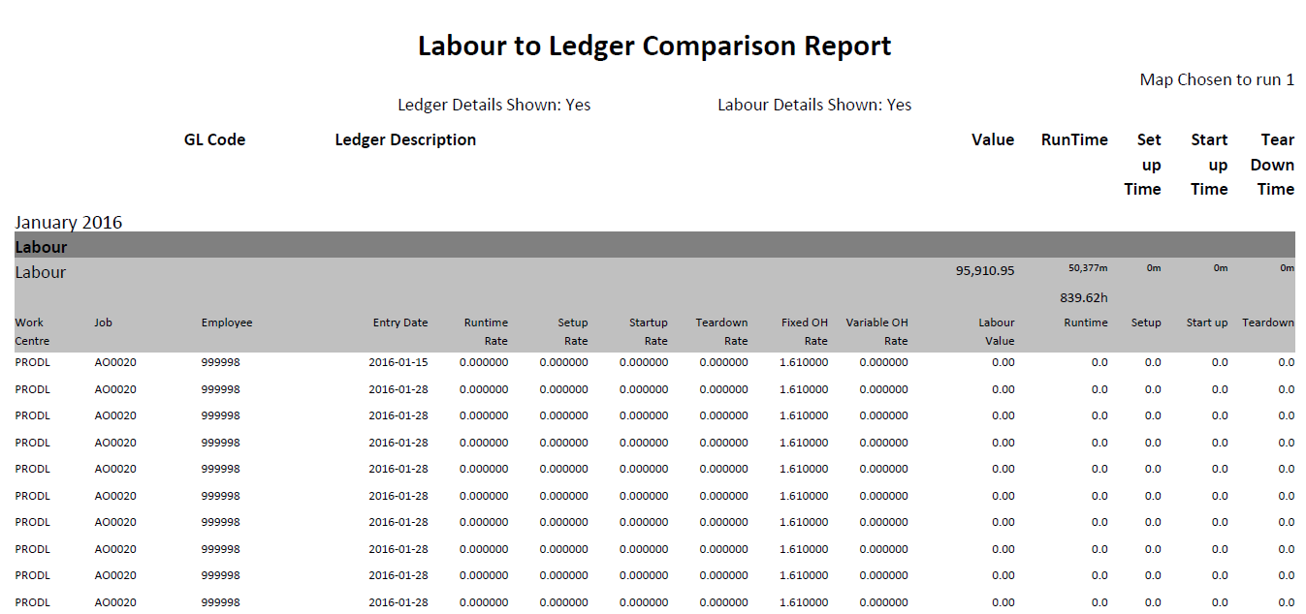

## Lot Traceability

|  |  |
| --- | --- |
| Description | Search to see where a lot has been used |
| Requested by | Matt Fantham |
| Delivered Date | N/A |
| Used by | N/A |

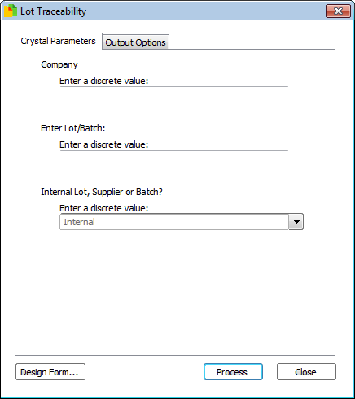Parameters

These are filters picked before running the report

* Company
  + The Syspro company ID to run against (PBL = 10)
* Lot/Batch
  + Choose lot or Batch to run against
* Supplier/Internal
  + Supplier – search supplier lot numbers
  + Internal – search internal lot numbers
  + Batch – search batch numbers

Final Report

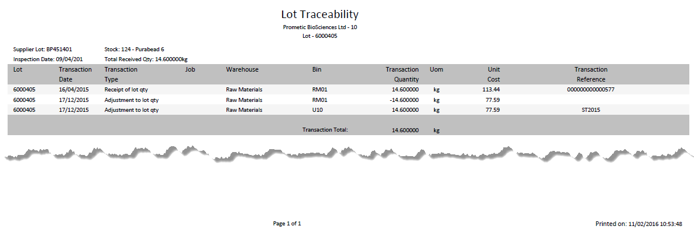

## Missing RI2 GLGroups

|  |  |
| --- | --- |
| Description | Review of all GL Codes that are missing either a GLGroup or ReportIndex2 (for use in finance reports) |
| Requested by | Bianca Vasquez |
| Delivered Date | N/A |
| Used by | N/A |

Parameters

These are filters picked before running the report

* + None

Final Report

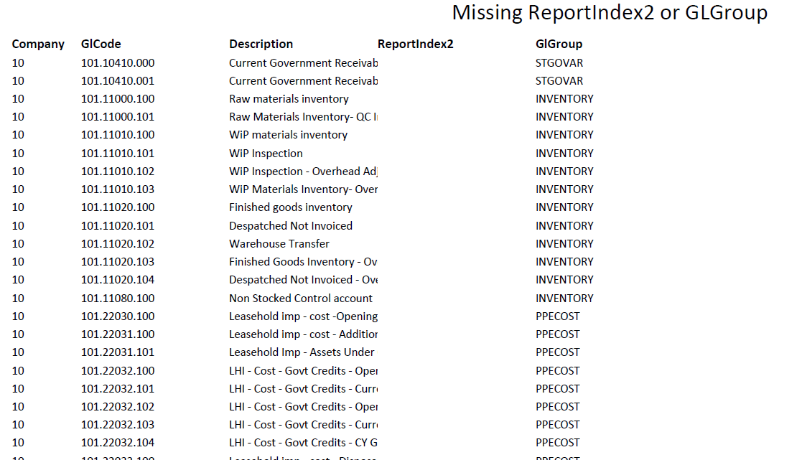

## Open Requisition Report

|  |  |
| --- | --- |
| Description | Monitoring requisitions that require approval |
| Requested by | Benjamin Hémond |
| Delivered Date | N/A |
| Used by | PBI purchasing |

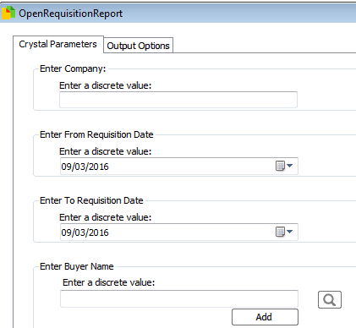Parameters

These are filters picked before running the report

* Company
  + The Syspro company ID to run against (PBL = 10)
* Enter from Requisition Date
  + Start of requisition date period
* Enter to Requisition Date
  + End of requisition date period
* Buyer Name
  + If completed, then only run against this buyer

Final Report

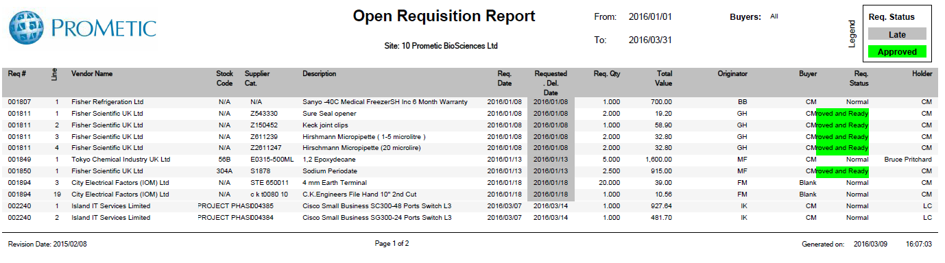

## Open Purchase Orders Stock

|  |  |
| --- | --- |
| Description | Monitor outstanding stock in purchase orders for manufacturing projects |
| Requested by | Matt Fantham |
| Delivered Date | N/A |
| Used by | PBL Manufacturing |

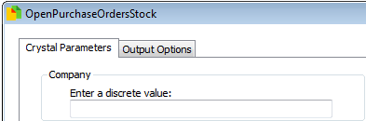Parameters

These are filters picked before running the report

* Company
  + The Syspro company ID to run against (PBL = 10)

Final Report

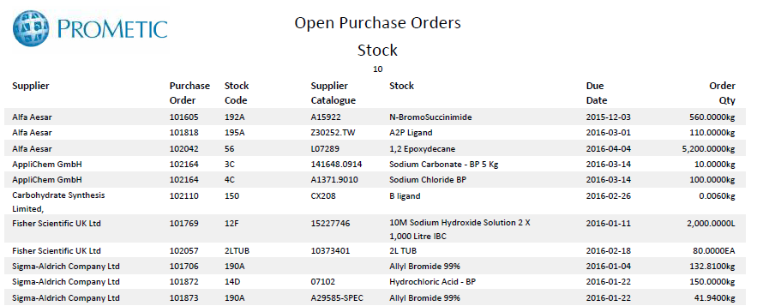

## Payment Run

|  |  |
| --- | --- |
| Description | New version of Payment run, allowing the original report to be run by Invoice number or payment number |
| Requested by | Bianca Vasquez |
| Delivered Date | N/A |
| Used by | PBI Finance |

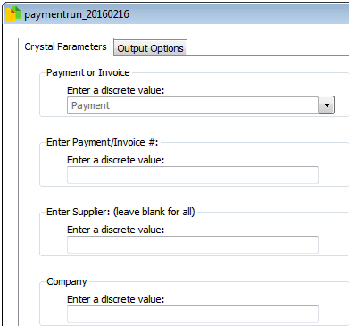Parameters

These are filters picked before running the report

* Company
  + The Syspro company ID to run against (PBL = 10)
* Payment/Invoice
  + Payment – search by payment number
  + Invoice – search by invoice number
* Payment/Invoice #
  + The reference to search
* Supplier
  + If completed, then only run against this Supplier

Final Report

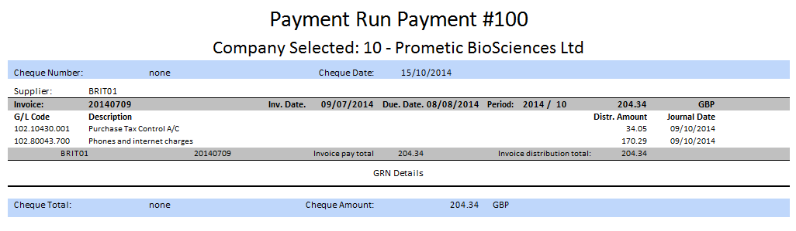

## Pick List

|  |  |
| --- | --- |
| Description | Report to find all stock for planned job (and all relevant sub jobs) |
| Requested by | Bryan Vickers |
| Delivered Date | N/A |
| Used by | PBP Manufacturing |

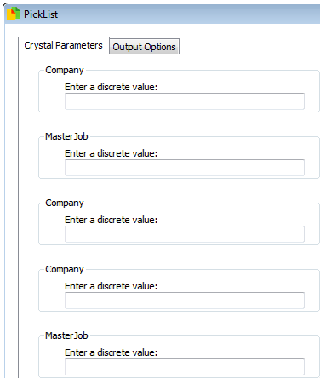Parameters

These are filters picked before running the report

* Company
  + The Syspro company ID to run against (PBL = 10)
* Master Job
  + Project job to search for

Final Report

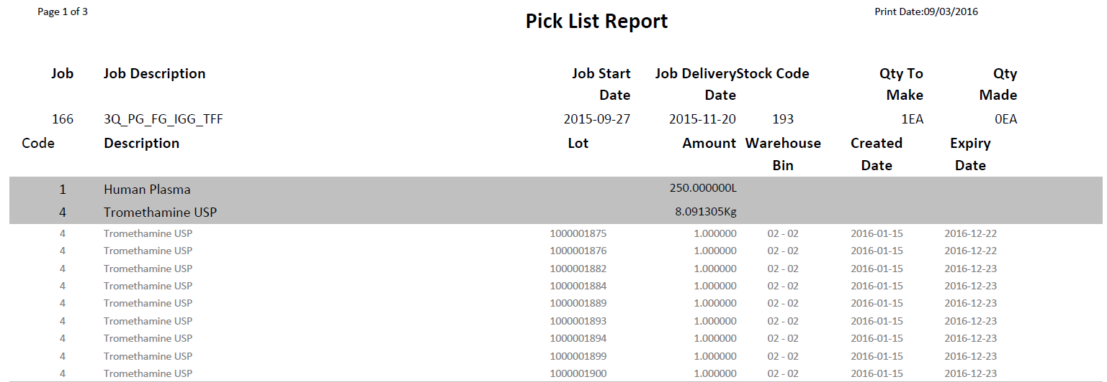

## Pick List Job Breakdown

|  |  |
| --- | --- |
| Description | Report to find all stock for planned job (and all relevant sub jobs), split by each job |
| Requested by | Bryan Vickers |
| Delivered Date | N/A |
| Used by | PBP Manufacturing |

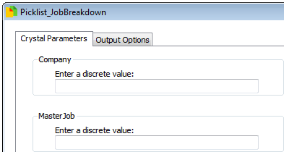Parameters

These are filters picked before running the report

* Company
  + The Syspro company ID to run against (PBL = 10)
* Master Job
  + Project job to search for

Final Report

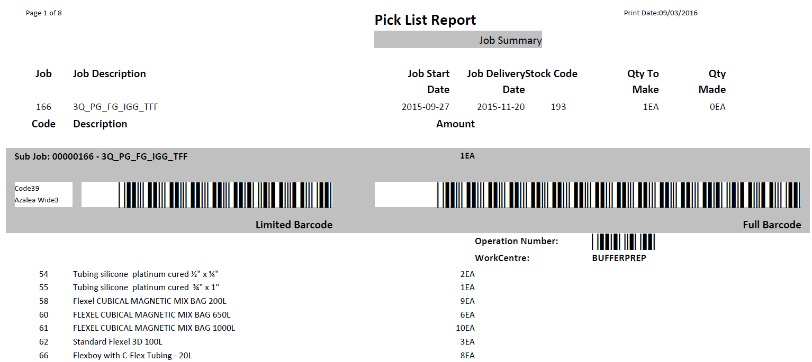

## Pick List Reserved Lots

|  |  |
| --- | --- |
| Description | Report to find all reserved stock for planned job (and all relevant sub jobs) |
| Requested by | Bryan Vickers |
| Delivered Date | N/A |
| Used by | PBP Manufacturing |

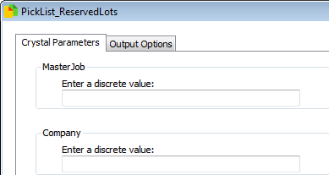Parameters

These are filters picked before running the report

* Company
  + The Syspro company ID to run against (PBL = 10)
* Master Job
  + Project job to search for

Final Report

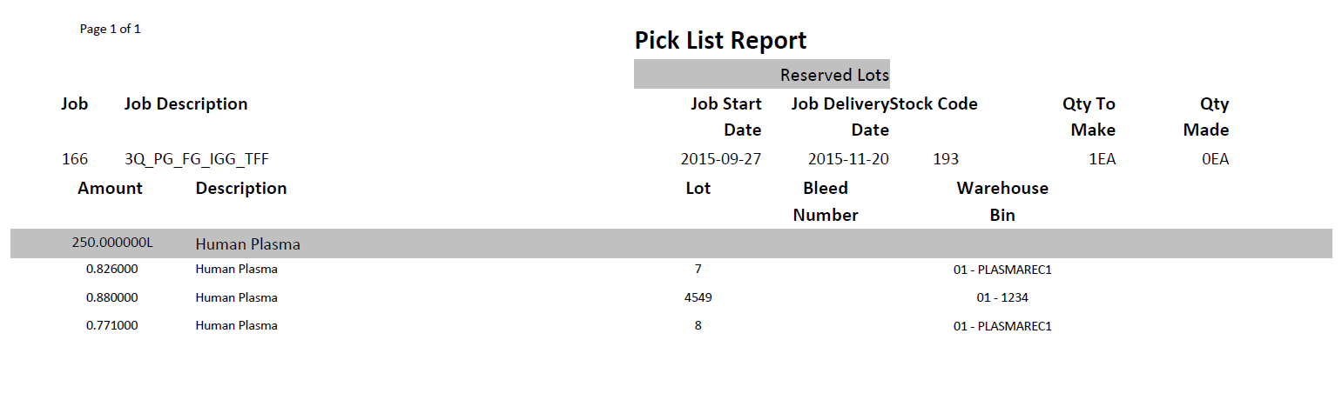

## Pick List Work Centre

|  |  |
| --- | --- |
| Description | Report to find all stock for planned job (and all relevant sub jobs), split by each work centre |
| Requested by | Bryan Vickers |
| Delivered Date | N/A |
| Used by | PBP Manufacturing |

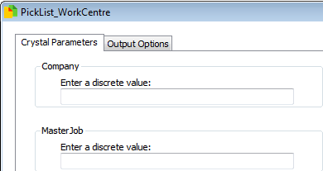Parameters

These are filters picked before running the report

* Company
  + The Syspro company ID to run against (PBL = 10)
* Master Job
  + Project job to search for

Final Report

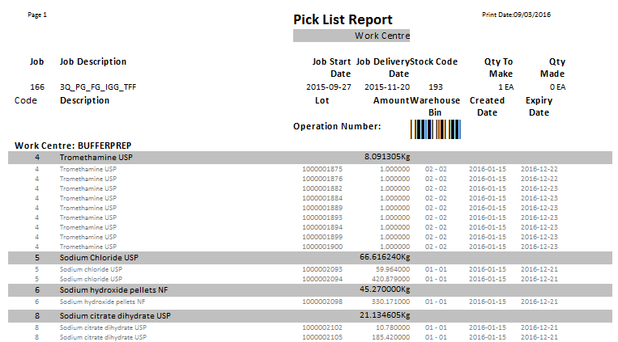

## Purchase Order Details

|  |  |
| --- | --- |
| Description | Provide details of Purchase Orders for a specified period of time |
| Requested by |  |
| Delivered Date |  |
| Used by |  |

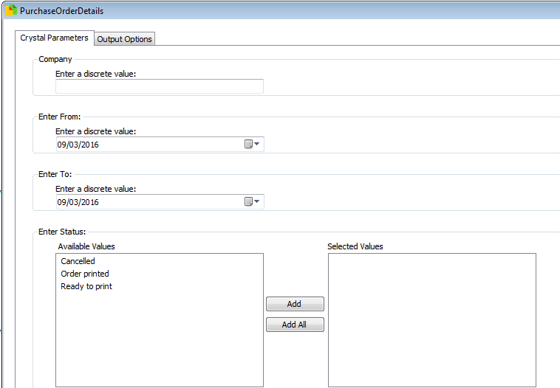Parameters

These are filters picked before running the report

* Company
  + The Syspro company ID to run against (PBL = 10)
* Enter from
  + Start of period of entry dates
* Enter to
  + End of period of entry dates
* Status
  + Purchase Order status to run against

Final Report

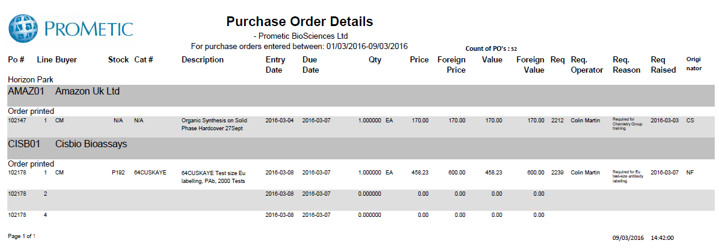

## Purchase Order E Signature

|  |  |
| --- | --- |
| Description | Report of changes made to purchase orders between two dates |
| Requested by | Liz Collins |
| Delivered Date | N/A |
| Used by | PBL Finance |

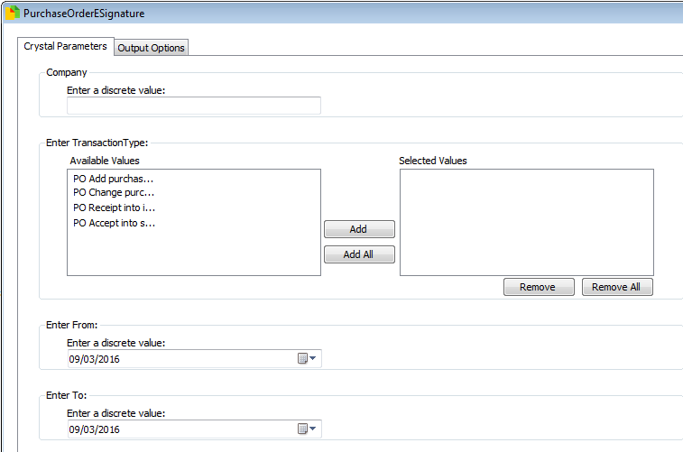Parameters

These are filters picked before running the report

* Company
  + The Syspro company ID to run against (PBL = 10)
* Transaction Type
  + Type of changes to run against
* Enter From
  + Start of period for date of change
* Enter To
  + End of period for date of change

Final Report

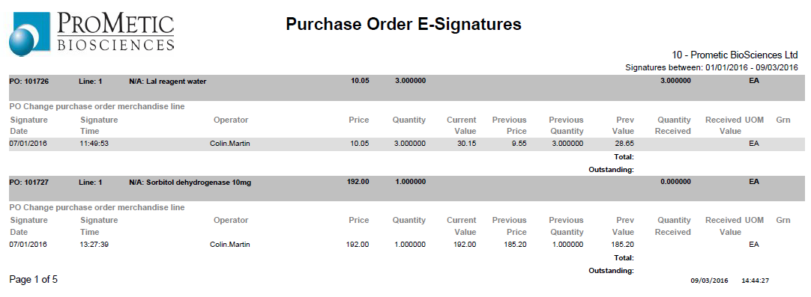

## Unpaid Assets Accounts Payable

|  |  |
| --- | --- |
| Description | Accounts Payable – Unpaid Assets, created by Prometic |
| Requested by | Bianca Vasquez |
| Delivered Date | - |
| Used by | PBI/PBL finance |

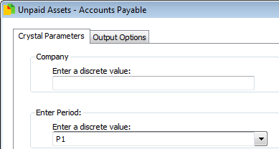Parameters

These are filters picked before running the report

* Company
  + The Syspro company ID to run against (PBL = 10)
* Period
  + P1 – this period
  + P2 – last period
  + P3 – last period - 1

Final Report

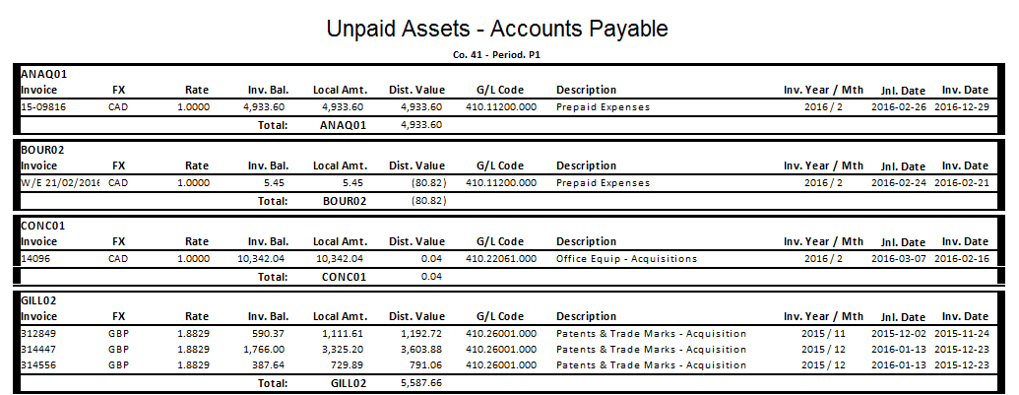

# Reports to be developed

The following reports are scheduled to be developed following the sign off of Actual Budgets Balance Sheet.

#### Actuals Budgets Financial Statement

#### Actuals Budgets Trial Balance

#### Actuals Budgets Budget vs Actual

#### Actuals Budgets Mapping Check